Multiple-choice section

Question 1 [2.1]

Which of the following is a factor of 42?

A 8 B 12 C 6 D 9

Question 2 [2.2]

The first five prime numbers are:

A 1, 2, 3, 5, 7 B 0, 1, 3, 5, 9 C 1, 2, 3, 4, 5 D 2, 3, 5, 7, 11

Question 3 [2.5]

Which is the correct statement?

A 5 + 2 < 3 – 5 B 0 – 8 < 4 + 10 C 4 – 6 < 8 – 11 D 14 + 6 < -10 + 2

Question 4 [2.1]

The common factors of 12 and 16 are:

A 1, 2, 6, 8 B 1, 2, 4 C 2, 3, 4, 6 D 2, 4

Question 5 [2.5]

Calculate the following: 6 – 4 – 5

A -3 B 1 C 15 D -10

Question 6 [2.1]

543 687 is divisible by:

A 6 B 2 C 9 D 3

Question 7 [2.4]

Which set of numbers is in ascending order?

A 0, 4, 2, 6 B 9, 6, 3, 1 C -11, 9, 8, -2 D 2, 3, 7, 11

Question 8 [2.6]

Calculate: 8 – (-4)

A 12 B 4 C -4 D -12

Question 9 [2.7]

-12 – (-2) – (+2) simplifies to:

A -12 – 2 – 2 B -12 + 2 + 2 C -12 + 2 – 2 D -12 – 2 + 2

Question 10 [2.3]

The number 16 expressed as a product of its prime factors is:

A 2 × 2 × 4 B 2 × 2 × 2 × 2 C 1 × 2 × 2 × 2 × 2 D 2 × 8

Question 11 [2.2]

Which of the following is a pair of composite numbers?

A 5 and 12 B 23 and 31 C 30 and 38 D 19 and 25

Question 12 [2.1]

The highest common factor of 8 and 12 is:

A 12 B 8 C 4 D 96

Multiple-choice total marks: ____ / 12

Short answer section

Question 13 2 marks [2.1, 2.4]

Use words from the list below to complete the following sentences.

*multiple factor integers negative common factor*

(a) A number that divides exactly into another number is a ______________.

(b) All whole numbers, both negative and positive and the number zero are known as __________________.

Question 14 2 marks [2.2]

Explain what is meant by the term ‘co-prime’. Use an example to help you explain.

Question 15 3 marks [2.1]

Find the lowest common multiple of the following sets of numbers.

(a) 6 and 8 (b) 4 and 6 (c) 9 and 15

Question 16 3 marks [2.1]

Find the highest common factor of the following pairs of numbers.

(a) 18 and 32 (b) 36 and 54 (c) 56 and 72

Question 17 3 marks [2.1]

Determine which of the numbers 60, 81, 435 and 2892 and 7296:

(a) are divisible by 3 (b) are divisible by 6 (c) are divisible by 8

Question 18 2 marks [2.1]

Sliced cheese comes in a packet of 12 and bread rolls come in a packet of 10. What is the least number of packets of each that can be bought to make cheese rolls and have no cheese or bread rolls left over?

Question 19 2 marks [2.2]

List the prime numbers between 30 and 50.

Question 20 2 marks [2.2]

List the composite numbers between 120 and 140.

Question 21 3 marks [2.2]

Which of the following pairs of numbers are co-prime. State your reasons.

(a) 14 and 15 (b) 14 and 21 (c) 15 and 28

Question 22 2 marks [2.3]

Draw a factor tree for the number 96, then express 96 as a product of its prime factors in index form.

Question 23 3 marks [2.3]

Use prime factors to find the HCF for 40 and 72.

Question 24 4 marks [2.3]

What number is the product of each of these prime factorisations?

(a) 34 × 82 (b) 24 × 33 × 52

Question 25 2 marks [2.4]

Find the next three numbers in each pattern.

(a) 17, 11, 5, __________, __________, __________

(b) 26, 12, -2, __________, __________, ___________

Question 26 3 marks [2.5]

Write a > or < symbol between each expression to make a correct statement.

(a) +10 – 5__________ -9 + 8

(b) -8 – 5 __________ -4 – 6

(c) 0 + 2__________ -5 + 8

Question 27 2 marks [2.4]

Write in ascending order: -4, 14, 0, 4, -2, 2

______, _______, ______, _______, ______, ______

Question 28 2 marks [2.4]

Write in descending order: -15, -25, -5, 20, -20, 5

______, _______, ______, _______, ______, ______

Question 29 2 marks [2.4]

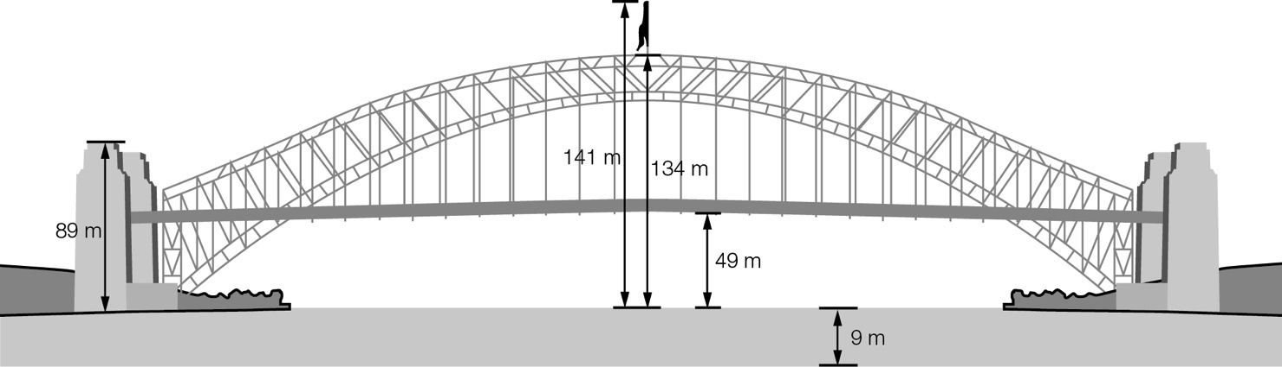

(a) What is the distance from the top of the arch to the bottom of the ocean?

(b) What is the distance from the top of the communications pole to the bottom of the deck?

Question 30 3 marks [2.5]

Calculate the following.

(a) 6 + 8 + 14

(b) -4 + 3 + 2

(c) 19 – 15 – 11

Question 31 2 marks [2.5]

Kalinda observes a spider about 3 cm below the windowsill. She watches the spider move 12 cm up the wall, then 5 cm down the wall. The spider then continues a further 9 cm down the wall, before turning to climb 7 cm up the wall. How far is the spider from the windowsill?

Question 32 3 marks [2.6]

Calculate the following.

(a) 12 + (-6) + (-4)

(b) -3 + (-5) + (-6)

(c) 18 – (-8) – (-10)

Question 33 2 marks [2.6]

Write the following number sentences in words.

(a) -10 + (-4) = -14

(b) +9 – (-6) = +15

Question 34 3 marks [2.5]

Calculate the following.

(a) -11 + 4 – 9

(b) 32 – 18 – 26

(c) -22 – 9 + 11

Question 35 2 marks [2.7]

The school canteen keeps records of the profits and losses over a week. These records are shown in the table. Find the school canteen’s profit or loss for the week.

|  |  |
| --- | --- |
| Day | Result |
| Monday | Profit $35 |
| Tuesday | Profit $50 |
| Wednesday | Profit $20 |
| Thursday | Loss $10 |
| Friday | Loss $25 |

Question 36 2 marks [2.7]

State true or false for the following.

(a) 30 – (-10) = 30 + 10

(b) 15 + (-5) = 15 + 5

Short answer total:_________/59

Extended answer section

Question 37 2 marks [2.7]

The following table shows the average daily temperature (°C) recorded at the South Pole. What is the average daily temperature for April?

|  |  |  |  |  |  |  |  |  |  |  |  |  |
| --- | --- | --- | --- | --- | --- | --- | --- | --- | --- | --- | --- | --- |
| Jan | Feb | Mar | Apr | May | Jun | July | Aug | Sept | Oct | Nov | Dec | Total |
| -28 | -41 | -54 |  | -57 | -58 | -60 | -60 | -60 | -51 | -39 | -28 | -593 |

Question 38 4 marks [2.1]

A donut shop has made 36 chocolate donuts, 27 strawberry donuts and 18 caramel donuts. The donut shop wants to sell boxes with a combination of the three types of donuts. How many boxes will there be and how many of each donut will there be in each box if each box has the same total number of donuts?

Question 39 4 marks [2.2]

What is the smallest prime number that can be expressed as the sum of three consecutive prime numbers and the sum of six consecutive prime numbers?

Question 40 2 marks [2.2]

Charlie’s age is a prime number greater than 50. The sum of the digits in Charlie’s age is also a prime number. If you add a multiple of 13 to his age the result is 100. How old is Charlie?

Question 41 3 marks [2.6]

Create number sentences using the following number cards and the operations addition or subtraction to make each of the numbers below. You can use each number card as many times as you like.

.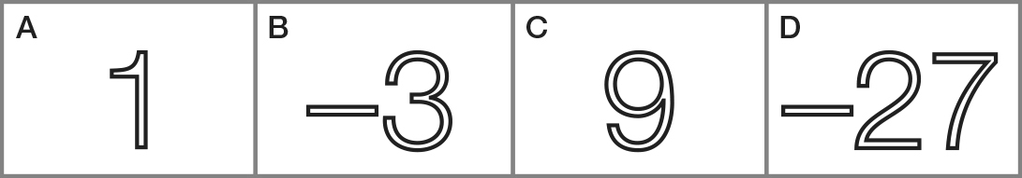

(a) 50 (b) 38 using only four cards (c) -11

(cards may be repeated)

Extended answer total:_________/15

TOTAL test marks: _______ / 86